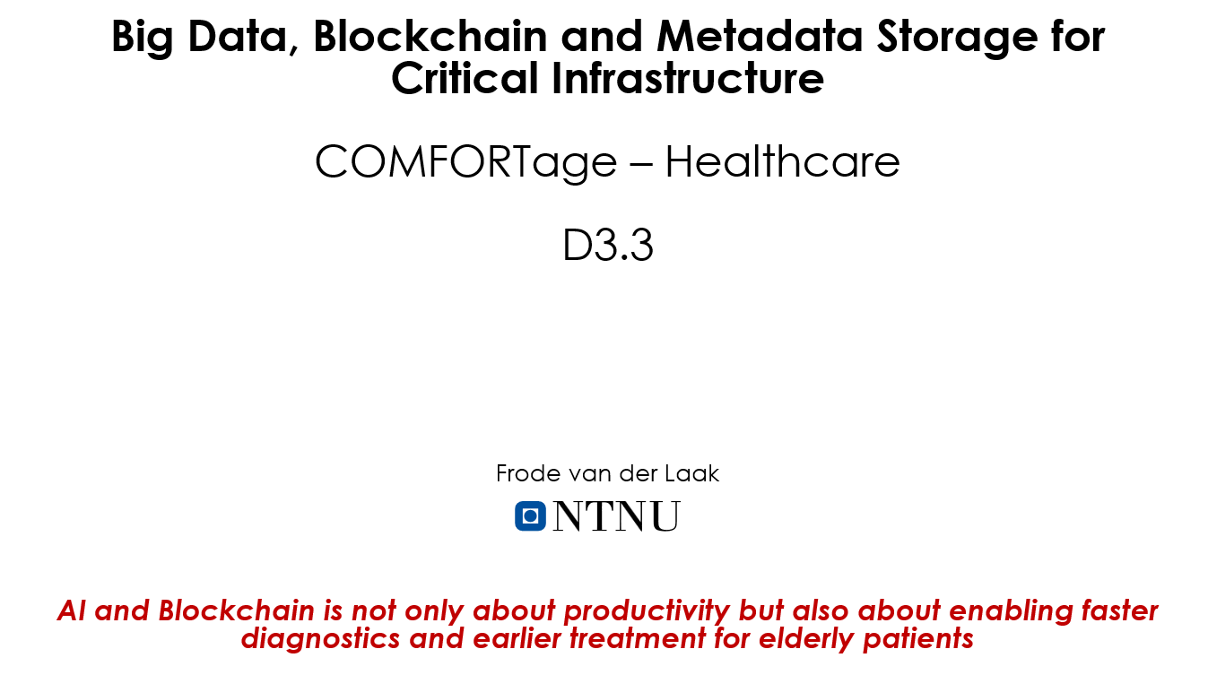

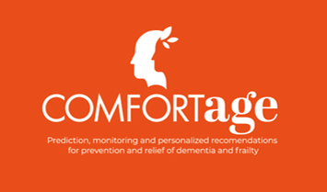

Software requirement Specification(SRS)

Contents
1. Introduction 3
2. Layer 1 PoA blockchains 4
3. Project phase: 5
4. Project Development Schedule 9
5. Software Tools Used in the Project 9
6. Project block diagram 10
6.1 Description: 10
6.2 Workflow 11
7. Smart Contract: 14
7.1 List of variables 14
8. Data structure 17
9. Decentralized Application(Dapp) 21
10. Zero Trust System 24

List of Figures:
Figure 1:Project Block Diagram 9
Figure 2: Sign up on page 20
Figure 3: Login page 20
Figure 4: Personal information Page 21

Introduction
Dementia is a broad term that describes a decline in cognitive function severe enough to interfere with daily life. It refers to a collection of symptoms caused by various brain disorders rather than a single disease. Common symptoms include memory loss, difficulties with thinking, problem-solving, communication, and mood changes. There are several forms of dementia, with Alzheimer's disease being the most prevalent, often characterized by memory loss and confusion. Vascular dementia results from reduced blood flow to the brain, commonly following a stroke. Lewy body dementia is associated with abnormal protein deposits in the brain, while frontotemporal dementia affects behavior and language due to damage in the frontal and temporal lobes. Dementia is generally progressive, meaning symptoms worsen over time. While some treatments can help manage the symptoms, there is currently no cure for most types of dementia.
The COMFORTage project is at the forefront of innovation in dementia prevention and aging research. It pioneers new approaches to these challenges, with requirement analysis forming a key project component. This involves thoroughly examining current health interventions, digital health technologies, and personalized care frameworks. By integrating cutting-edge research, technological advancements, and clinical practice, COMFORTage aims to bridge the gap between scientific understanding and practical application in dementia care and aging. Its comprehensive approach informs future project strategies, positioning COMFORTage as a leader in the field.

Layer 1 PoA blockchains
In recent years, blockchain technology has gained significant attention and widely adopted across various industries. One of the critical challenges in blockchain networks is achieving consensus among the participants. The Proof of Authority (PoA) consensus algorithm is famous for its scalability and energy efficiency. This section presents state of the art in PoA blockchain networks and explores the utilization of 5G mobile connections as nodes in Layer 1 PoA blockchains for microtransactions. PoA, or Proof of Authority, is an algorithm used with blockchains and is responsible for delivering fast transactions through a consensus mechanism based on identity as a stake. VeChain, Reltime, and Xodex are the most notable PoA platforms.
The approved accounts in PoA-based networks corroborate the transactions and blocks. These are known as validators. The validators run the software and allow them to put the transactions in blocks. This process is automated, and there is no requirement for the validators to monitor the computers. Proof of Authority (PoA) is a consensus algorithm that relies on a set of trusted authorities or validators to validate transactions and create new blocks. Unlike Proof of Work (PoW) and Proof of Stake (PoS) algorithms, where participants compete or stake their tokens, PoA requires validators to be identified and authorized by the network. In PoA, block validators are known entities with known addresses and public keys, making it easier to identify bad actors.
Validators are typically selected based on their reputation, expertise, or stake in the network. Once authorized, a validator can participate in block creation and transaction validation. The consensus is achieved when most validators agree on the validity of transactions and the order of blocks. PoA consensus offers several advantages over other consensus algorithms. It eliminates the need for resource-intensive mining or staking, resulting in lower energy consumption and increased scalability. PoA also provides faster block confirmation times, making it suitable for applications that require high transaction throughput.

Project phase:

We divided it into two phase
- Phase 1, our primary integration phase, is a collaborative effort. It is pilot-driven, with the pilot actively interacting with the system. They will take the patient's record and push it into the blockchain through the decentralized application. Once all stakeholders can view the complete picture of the system, we can collectively navigate into the second phase, further strengthening our collaborative approach.

- Phase 2 It is the advanced part of the project. In this phase, we will determine the scope of automating the system. Let’s say that every half an hour, we need to monitor the patient body temperature. Here, we can add a wearable with the patient’s body to measure the temperature, and the system automatically pushes the device into the blockchain without a nurse or attendance. It is an example of IoT integration with blockchain. In the same way, if a doctor wants to track the patient's movement. We can install a surveillance camera to track the patient autonomously.

Phase 1
- Finalise the Software Requirements Specification (SRS) document to ensure all requirements are well-defined and understood.
- Local Development Environment Setup
  - Establish the local development environment, including installing and configuring essential tools.
  - Tools to be installed:
  - Visual Studio Code (VS Code) - The primary code editor for writing, editing, and managing the project's codebase.
  - MongoDB - A NoSQL database that stores and manages the project's configuration and structured data.
  - Remix IDE - A browser-based IDE for writing, testing, and deploying Solidity smart contracts.
  - Node.js - A runtime environment for building the backend server and handling server-side logic.
  - Express.js (for backend processes) - A framework for structuring the backend, defining routes, and handling HTTP requests.
- Front-End Framework Installation
  - Install and configure front-end frameworks, ensuring compatibility:
  - HTML, CSS, JavaScript (JS)
  - , and React.js—Front-end Library.
  - Ensure proper versioning to avoid conflicts during deployment.
- IPFS Framework Installation and Configuration
  - Install and configure the InterPlanetary File System (IPFS) framework for decentralised file storage.
- Data Structure Design in Solidity
  - Master the art of designing and implementing data structures using Solidity, a crucial skill tailored to project needs.
- Configuration Table Setup in MongoDB
  - Create and configure the necessary tables in the MongoDB database.
- Smart Contract Development
  - - Write and optimise smart contracts using Solidity.
  - - Deploy, test, and debug smart contracts to ensure functionality and security.
- Decentralized Application (dApp) Development
  - - Develop the user interface for the decentralised application.
  - - Ensure smooth communication between the DApp and blockchain.
- IPFS Integration with DApp
  - - Implement and verify communication between the DApp and the IPFS server.
- Full Integration Testing
  - - Conduct comprehensive integration testing to validate the seamless operation of all components.

Phase 2:
- Sensor and Camera Installation
  - Install sensors and other solutions from the partners at the designated site to ensure accurate and reliable data capture.
  - Verify the proper functioning and calibration of all equipment.
- Data Collection from the Pilot
  - Initiate data collection from the pilot phase.
  - Ensure the data captured is comprehensive and relevant for the subsequent AI model development.
- Data Preparation
  - Clean and preprocess the collected data to make it suitable for AI model training.
  - Perform data normalization, feature extraction, and labeling as needed.
- AI Model Creation (Potential MSc Project)
  - Design the AI model architecture tailored to the project’s specific requirements.
  - Define the necessary algorithms and techniques for optimal model performance.
- AI Model Training (Potential MSc Project)
  - Train the AI model using the prepared dataset.
  - Apply appropriate training methods to achieve high accuracy and generalization.
- Model Testing (Potential MSc Project)
  - Conduct rigorous testing of the AI model to assess its performance on unseen data.
  - Identify and address any issues or inaccuracies.
- Model Performance Metrics Calculation.
  - Calculate performance metrics such as accuracy, precision, recall, F1 score, and others to evaluate the AI model’s effectiveness.
  - Document the results and use them to refine the model if necessary.
- AI Integration with Front-End (Potential MSc Project).Seamlessly integrate the AI model into the front-end application.Ensure that the AI-driven features are user-friendly and responsive.
- Final Submission
  - Prepare and submit the final version of the project, ensuring all deliverables are met and documented.
- User Feedback Collection.
  - Gather user feedback to evaluate the system’s performance and satisfaction.Collect detailed feedback through surveys, interviews, and direct user interaction.
- System Tuning Based on Feedback.
  - Analyse the feedback received and implement necessary adjustments to improve system performance. Focus on addressing any issues raised by users and enhancing overall functionality.
- Ongoing System Updates.
  - Regularly update the system to incorporate new features, improvements, and optimisations. Ensure the system remains up-to-date and continues to meet user needs over time.

Project Development Schedule

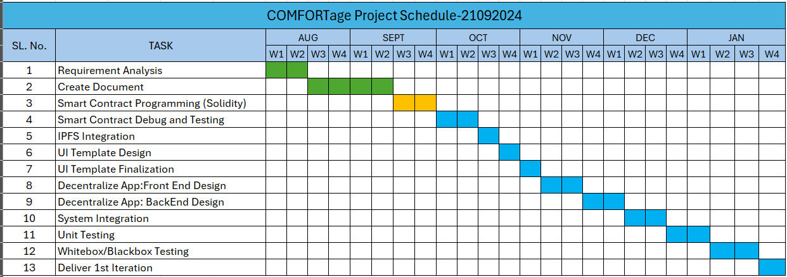

Software Tools Used in the Project

Technology Stack
Consensus Mechanism: Proof of Authority (PoA)
Programming Language: Solidity (for smart contracts)
Development Tools: Truffle, Remix, Ganache
Message Queuing: RabbitMQ
Programming Language: Solidity
Development Tools: Ruffle, Remix, Ganache

Backend System
Programming Language: Python
Framework: Django
Database: PostgreSQL
API Development: Django REST framework
Web Applications, Framework: React.js

Security and Compliance
Security Libraries: Web3.js (JavaScript)
Compliance Tools: OpenZeppelin (for security audits)
Zero Trust: Built Zero Trust for the entire solution.

Project block diagram
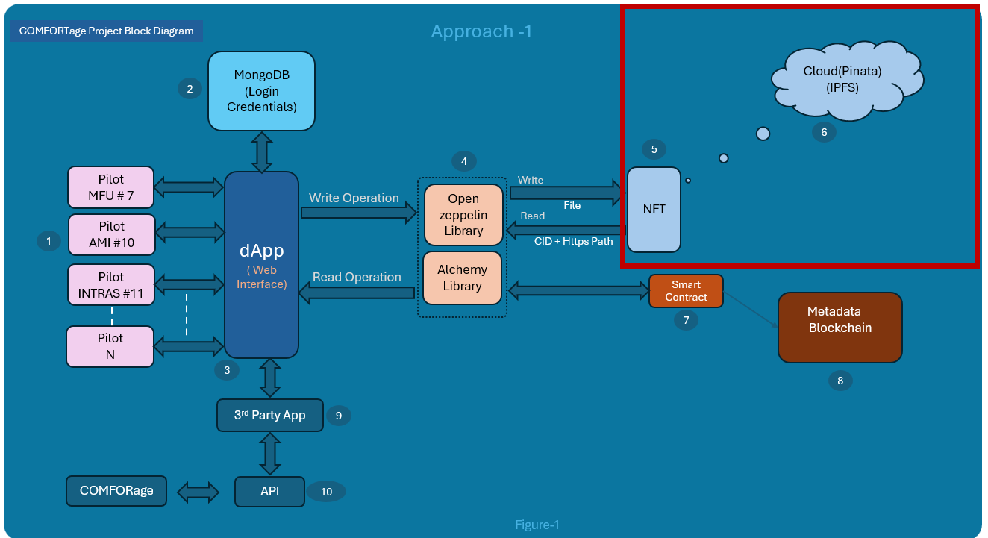
Figure 1:Project Block Diagram

Description:
This diagram appears to outline the architecture of a decentralized application (Dapp) that interacts with multiple components, including MongoDB, smart contracts, third-party apps, and an API. Here's a detailed breakdown of the various components in the image, based on the labeled numbers:
- Pilots (MFU #7, AMI #10, INTRAS #11, Pilot N):
  - These seem to represent different pilots or client modules that interact with the Dapp. Each pilot module likely represents a distinct user or system using the application. These modules feed data into the Dapp.
- MongoDB (Login Credentials):
  - The Dapp connects to MongoDB to handle login credentials or other data storage needs. MongoDB stores and retrieves data files, potentially for user management or transaction logs.
- Dapp (Web Interface):
  - The core of the system is the Dapp, which serves as the main interface for users to interact with the blockchain, smart contracts, and other parts of the system.
  - It interacts with various pilots, MongoDB, smart contracts, and external third-party apps.
  - The Dapp likely facilitates both read and write operations to the blockchain and MongoDB.
- Library Framework (OpenZeppelin, Alchemy): (Frame around)
  - The Dapp uses two libraries/frameworks for blockchain interaction:
    - OpenZeppelin: A widely-used framework for deploying secure smart contracts.
    - Alchemy: A blockchain infrastructure provider that helps developers build scalable Dapps. This is likely used to interface with the blockchain for transaction management and retrieving metadata from smart contracts.
- Smart Contract:
  - The smart contract is a core element connected to the Dapp. It likely contains the business logic governing blockchain transactions. The Dapp reads metadata from the smart contract and sends write operations to it, which eventually get committed to the blockchain.
- Blockchain:
  - This represents the final storage and execution layer for transactions. The blockchain interacts with the smart contracts, ensuring that any interactions done via the Dapp are securely committed.
- 3rd Party App:
  - The Dapp has integration with an external third-party application. This could be an analytics platform, payment processor, or another external service providing additional functionality.
- API:
  - The Dapp also interacts with an external API, likely to fetch data or communicate with other systems.

Workflow
When deploying the system for user access, the process follows these steps:
- User Sign-Up:
  - The user initiates interaction by accessing the web interface and creating an account.
  - Once the account is created, an admin receives a notification for approval. Upon approval, the user gains access to the system’s operations.
- Database Management:
  - User credentials, access rights, and project settings are securely stored in a central database.
- Decentralised Application (Dapp):
  - The Dapp manages user interactions within the system, ensuring seamless communication between the user interface and backend processes.
- Metadata and Blockchain Integration:
  - The Dapp sends the file to the IPFS cloud upon data entry, retrieving a content ID (CID) and file URL.
  - This metadata is then forwarded to smart contracts responsible for writing it into the blockchain.
- Smart Contracts and NFTs:
  - Files stored within IPFS are assigned unique identifiers as Non-Fungible Tokens (NFTs), ensuring that each document is immutable and easily retrievable.
- Third-Party Integration:
  - External applications can interact with the system, thoroughly verifying all content before integration.
When the system is deployed and submitted for the user's access, it is entirely blank. We provide a web interface for the user to interact with.
- At first, the user opens the web interface and creates an account using the “Sign up” button. The admin will receive a mail. Once the admin is approved using the admin panel, the user can access the operation. In the figure, mark-1 is the user. We showed the three pilots here. In a real scenario, N users can access the system.
- Mark-2 is the database storing user credentials, access rights, and different project-related settings.
- The mark-3 is the decentralised application(Dapp). The user interaction is handled by a decentralised application that resides inside the cloud server.
- The mark-4 is the collection of the library framework, which is responsible for flawlessly communicating with blockchain and IPFS. When a user wants to write data for the blockchain, the Dapp processes it. At first, it sends the file to the cloud IPFS and gets the content ID(CID) and file URL path. Then, Dapp created a JSON structure called metadata. The metadata is sent to the smart contracts. Then, the metadata is written into the blockchain memory.
- Mark-5 is the Non-Fungible Token(NFT). All files stored inside the IPFS are nonfungible. Every file holds a unique ID. Users can fetch this file by sending the unique document identifier from the IPFS.
- The Mark-6 is the IPFS, which resides inside the cloud interface. Here, we showed one website, Pinata, a popular IPFS cloud platform. Other popular platforms are available where we can store our files decentralised.
- Mark-7 is a smart contract written using Solidity language. It is responsible for receiving metadata from the user and writing to the blockchain. When the user wants some information, it fetches the data from the blockchain memory. The Dapp then displays it to the user interface.
- Mark-8 is the blockchain; it is EVM-compatible. Our programming language is Solidity, which can only be deployed inside the blockchain.
- Mark-9 is the third-party app provider module that handles all communication outside the system. All received content is first verified and thoroughly checked for authenticity. Once it is passed, the information is provided to the client.
- Mark-10 is the list of APIs facilitating various query functions to send/receive the data.

Smart Contract:

List of variables
This is list of variable of the questionary to the pilots.
List of Data Inputs for Dementia Analysis | MFU # 7 | AMI #10 | INTRAS #11
Personal Medical Records.
1. Personal Information:
- Name |  | x | X
- Date of Birth | X | x | X
- Gender | X | x | X
- Contact Details |  | x
2. Medical History:
- Past Medical Conditions | X | x | X
- Surgeries |  | x
- Chronic Diseases | X | x | X
3. Medications:
- Current Medications | X | x | X
- Past Medications |  | x | X
- Dosages | X | x | X
4. Diagnoses:
- Details of Dementia Diagnosis |  |  | X
- Type of Dementia | X |  | X
- Stage and Progression | X | x | X
5. Lab Results:
- Blood Tests | X
6. Vital Signs:
- Blood Pressure | X | x | X
- Heart Rate | X | x | X
- Temperature | X |  | X
- Weight | X | x | X
7. Therapies:
- Cognitive Therapies | X
- Physical Therapies | X | x
- Occupational Therapies | X
8. Care Plans:
- Nursing Care | X
- Assisted Living Arrangements | X
9. Lifestyle Recommendations:
- Exercise |  | x
10. Patient Consent:
- Records of Patient Consent for Treatments |  | x | X
- Data Sharing | X | x | X
- Research Participation | X | x | X

List of Data Inputs for Dementia Analysis | MFU # 7 | AMI #10 | INTRAS #11
11. Access Permissions:
- Control Over Who Can Access, View, and Modify Records | X |  | X
12. Family History:
- Information about Dementia in Family Members |  | x | X
13. Clinical Trials:
- Data from Clinical Trials Involving Dementia Patients | X |  | X
14. Study Results:
- Findings from Studies and Research Involving Patient Data | X |  | X
15. Dental History:
- Conditions | X
16. Activity Logs:
- Data from Fitness Trackers or Apps (Steps Taken, Exercise Routines) | X | x
- Sleep Patterns | X
17. Exercise Plans:
- Personalized Exercise Recommendations |  | x
- Progress Tracking |  | x
18. Food Intake Logs:
- Records of Daily Food Intake |  | x
19. Living Conditions:
- Information about the Patient's Living Environment | X |  | X
20. Social History:
- Lifestyle Factors | X |  | X
- Employment Status |  | x | X
- Social Support Networks |  |  | X
21. Rehabilitation Plans:
- Detailed Plans for Physical, Occupational, and Speech Therapy |  | x
22. Progress Reports:
- Regular Updates on the Patient’s Progress in Rehabilitation Programs |  | x
23. Device Readings:
- Data from Personal Health Devices (Blood Glucose Monitors, Heart Rate Monitors, Wearable ECGs) | X
24. Prescription History:
- Dosages |  | x
- Durations |  | x

Data structure
(Only for first 10, can you make a smartcontract for rest)
// SPDX-License-Identifier: MIT
pragma solidity ^0.8.0;

contract MedicalRecords {

struct PersonalInformation {
string name;
string dateOfBirth;
string gender;
string contactDetails;
}
struct MedicalHistory {
string[] pastMedicalConditions;
string[] surgeries;
string[] chronicDiseases;
}
struct Medication {
string medicationName;
string dosage;
bool isCurrent;
}
struct DementiaDiagnosis {
string diagnosisDetails;
string dementiaType;
string stage;
string progression;
}
struct LabResults {
string bloodTest;
}
struct VitalSigns {
string bloodPressure;
uint heartRate;
uint temperature;
uint weight;
}
struct Therapies {
string[] cognitiveTherapies;
string[] physicalTherapies;
string[] occupationalTherapies;
}
struct CarePlan {
string nursingCare;
string assistedLiving;
}
struct LifestyleRecommendations {
string exercise;
}
struct PatientConsent {
bool treatmentConsent;
bool dataSharingConsent;
bool researchParticipationConsent;
}
struct AccessPermissions {
address[] authorizedViewers;
address[] authorizedModifiers;
}
struct FamilyHistory {
string dementiaInFamily;
}
struct ClinicalTrialData {
string trialName;
string findings;
}
struct StudyResults {
string studyName;
string findings;
}
struct DentalHistory {
string conditions;
}
struct ActivityLog {
uint stepsTaken;
string exerciseRoutines;
string sleepPatterns;
}
struct ExercisePlan {
string recommendations;
string progressTracking;
}
struct FoodIntakeLog {
string[] dailyFoodIntake;
}
struct LivingConditions {
string livingEnvironment;
}
struct SocialHistory {
string lifestyleFactors;
string employmentStatus;
string socialSupportNetworks;
}
struct RehabilitationPlan {
string physicalTherapy;
string occupationalTherapy;
string speechTherapy;
}
struct ProgressReport {
string progressUpdate;
}
struct DeviceReading {
string deviceName;
string data;
}
struct PrescriptionHistory {
string medicationName;
string dosage;
uint duration;
}
// Main medical record structure containing all fields
struct MedicalRecord {
PersonalInformation personalInfo;
MedicalHistory medicalHistory;
Medication[] medications;
DementiaDiagnosis dementiaDiagnosis;
LabResults labResults;
VitalSigns vitalSigns;
Therapies therapies;
CarePlan carePlan;
LifestyleRecommendations lifestyleRecommendations;
PatientConsent patientConsent;
AccessPermissions accessPermissions;
FamilyHistory familyHistory;
ClinicalTrialData[] clinicalTrials;
StudyResults[] studyResults;
DentalHistory dentalHistory;
ActivityLog activityLog;
ExercisePlan exercisePlan;
FoodIntakeLog foodIntakeLog;
LivingConditions livingConditions;
SocialHistory socialHistory;
RehabilitationPlan rehabilitationPlan;
ProgressReport[] progressReports;
DeviceReading[] deviceReadings;
PrescriptionHistory[] prescriptionHistories;
}

// Mapping from patient address to medical records
mapping(address => MedicalRecord) private medicalRecords;

// Function to add or update personal information
function setPersonalInformation(
address patient,
string memory _name,
string memory _dateOfBirth,
string memory _gender,
string memory _contactDetails
) public {
medicalRecords[patient].personalInfo = PersonalInformation({
name: _name,
dateOfBirth: _dateOfBirth,
gender: _gender,
contactDetails: _contactDetails
});
}

// Other setter functions for updating medical record fields...

// Function to view personal information
function getPersonalInformation(address patient) public view returns (PersonalInformation memory) {
return medicalRecords[patient].personalInfo;
}

// Other getter functions for retrieving data from the record...
}

Explanation:
- Structs: Each section of the medical record (Personal Information, Medical History, Medications, etc.) is defined as a struct to logically group related data.
- Arrays: Some fields like pastMedicalConditions or medications are arrays, as they can have multiple entries over time.
- Mapping: The mapping(address => MedicalRecord) allows storing medical records for multiple patients, where each patient’s address serves as the key.
- Access Control: Access permissions are included to track who can view or modify the patient’s data, making the system compliant with privacy regulations.
- Flexible Data Handling: Arrays like medications, clinical trials, and progress reports allow for a dynamic list of entries, as these fields will grow over time with new data.
This data structure is designed to securely and decentralized handle the complexity of medical records, which fits well within a smart contract environment.

Decentralized Application(Dapp)
The figures below depict the design of the Dapp interface. The programmer can improve it, and the information below is for their reference only.
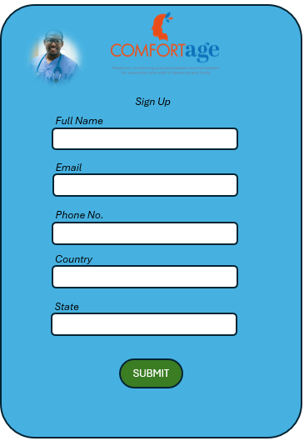

Figure 2: Sign up page

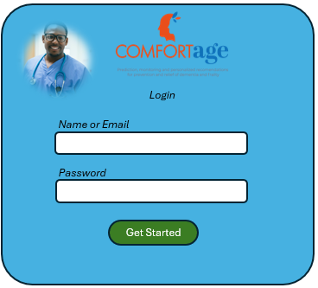
Figure 3: Login page

Figure 3: Sign up page

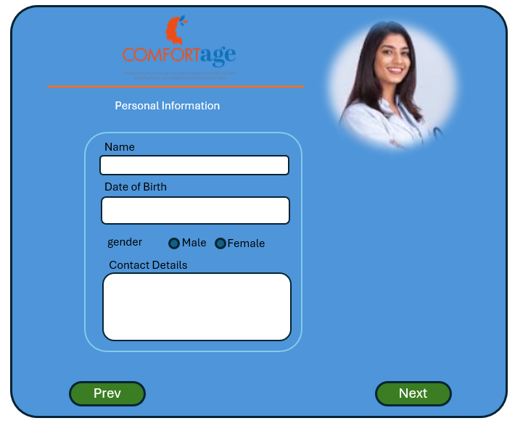
Figure 4: Personal information Page

Zero Trust System
Zero Trust is a security model and framework that assumes threats exist inside and outside a network. Unlike traditional security models that rely on perimeter-based defenses (like firewalls), Zero Trust operates on the principle of "never trust, always verify." No user, device, or application is trusted by default, whether inside or outside the network. Access is granted based on a continuous verification process, which includes strict identity and access management (IAM), multi-factor authentication (MFA), and least-privilege access controls.
Fundamental principles of Zero Trust include:
- Verification of Identity: Every user or device must be authenticated and authorized before accessing resources.
- Least Privilege: Users and systems are only given access to the resources they need to perform their tasks, minimizing the risk of unauthorized access.
- Micro-Segmentation: The network is divided into smaller zones, and access between them is tightly controlled, reducing the risk of lateral movement by attackers.
- Continuous Monitoring: All network activity is logged and monitored in real time to detect suspicious behavior.
- Assumed Breach: It is assumed that a breach may occur or already has, and security measures should be prepared to limit the potential damage.
Zero Trust is especially relevant for cloud environments, where users and devices are often distributed, and access can happen from various locations. It is designed to secure modern digital workplaces by addressing the security challenges of remote work, cloud services, and mobile devices.

